PT MERDEKA TSINGSHAN INDONESIA



**POLICY**

COMPANY STANDARD IT DEVICE

MTI-HRM-ICT-POL-001_Rev. 001

|  |
| --- |
| **Information Security Classification** |
| B – Business Information |

|  |  |  |  |  |  |
| --- | --- | --- | --- | --- | --- |
| **Rev.** | **Revision Status** | **Date** | **Prepared by** | **Reviewed by** | **Approved by** |
| 0 | Issued for Use | 21-NOV-2024 |  |  |  |
| C0 | Issued for Approval | 21-NOV-2024 | Widji Santoso | Ichsan Manzali | Clark Wu |
| B0 | Issued for Review | 21-NOV-2024 | Widji Santoso | Ichsan Manzali |  |
| A0 | Issued for Internal Discipline Review | 21-NOV-2024 | Widji Santoso |  |  |

# DISTRIBUTION LIST

|  |  |  |  |
| --- | --- | --- | --- |
| No. | Jenis | No. Salinan | Departemen |
| 1. | Soft copy | 01 | Seluruh departemen |
| 2. |  |  |  |
| 3. |  |  |  |
| 4. |  |  |  |
| 5. |  |  |  |
| 6. |  |  |  |
| 7. |  |  |  |
| 8. |  |  |  |
| 9. |  |  |  |
| 10. |  |  |  |
| 11. |  |  |  |

# DOCUMENT CHANGE STATUS

|  |  |  |  |  |  |  |
| --- | --- | --- | --- | --- | --- | --- |
| No. | Page | Section | Change Log | Revision by | Revision date | Revision version |
| 1. |  |  |  |  |  |  |
| 2. |  |  |  |  |  |  |
| 3. |  |  |  |  |  |  |
|  |  |  |  |  |  |  |
|  |  |  |  |  |  |  |
|  |  |  |  |  |  |  |
|  |  |  |  |  |  |  |
|  |  |  |  |  |  |  |
|  |  |  |  |  |  |  |
|  |  |  |  |  |  |  |
|  |  |  |  |  |  |  |
|  |  |  |  |  |  |  |
|  |  |  |  |  |  |  |
|  |  |  |  |  |  |  |
|  |  |  |  |  |  |  |

# Table of Contents

DISTRIBUTION LIST 2

DOCUMENT CHANGE STATUS 3

Table of Contents 4

1. Policy 5

2. Purpose 5

2.1. Scope 5

2.2. Objectives 5

3. Responsibilities 5

3.1. ICT Section: 5

3.2. Employees: 5

3.3. Department Heads: 5

4. Related Documents 6

5. General Standards 6

5.1. Policy 6

5.2. Replacement and Maintenance Standards 17

5.3. Depreciation Policy 18

5.4. Budgeting Computers 20

5.5. Other Provisions 20

6. Appendix 21

6.1. Service Request Form 21

6.2. Out of Policy Form 22

6.3. Berita Acara Kerusakan / Kehilangan Form 23

6.4. Disposal / Write-Off Form 24

# Policy

This policy established the standards for IT Devices PT. Merdeka Tsingshan Indonesia (MTI), such as computers and communication device. It is used to support efficient, secure and consistent IT operations. It defines the types of computers and IT devices used within the company, the responsibilities for maintaining these assets, replacement and budgeting criteria, ensuring compatibility with MTI’s business requirements.

# Purpose

The purpose of this policy is to ensure that MTI employees have standardized computer equipment that meets operational requirements and supports efficient IT management.

## Scope

This policy applies to all MTI employees and departments, including all the vendors who used the same communication device.

## Objectives

* To standardize computer types and specifications based on job functions.
* To standardize the communication device such as Radio Two Way.
* To define replacement and maintenance responsibilities.
* To facilitate budgeting and allocation for computer resources within MTI.

# Responsibilities

## ICT Section:

* Maintains and updates MTI’s computer standards every six months or as needed.
* Provides support only for MTI-issued devices that meet company standards.
* Ensure the IT Devices assets are maintained properly and comply with company policies.
* ICT section will not give any support to private computers, nor the purchase of computers and IT Devices with different types and brands from the standard policy.

## Employees:

* Responsible for the care and condition of MTI-issued devices, covering repair costs due to negligence.
* Ensures that company data on devices is stored and handled in compliance with MTI policies.
* Report to ICT Section for any issue and malfunction of the devices.

## Department Heads:

* Manage budgeting for new or upgraded computers as required by department needs.
* Allocate annual budget for additional computers and IT related devices, depending on the number of additional computers required in the following year. Include the upgrade of computer types and its peripheral, LED, software tools, additional printer, Big Screen Monitor, additional PC Desktop, etc.
* Submit any request related to IT devices via submit request form along with the cost code to ICT Section.
* Reallocation of computers within a Department shall be approved by the relevant Manager and reported to IT department for record.

# Related Documents

* STD-MCG-IT-001 Hardware and Software Standard Jul 2025
* PRO-MCG-IT-0001 - Out of Policy Customization Procedure
* MTI-HRM-ICT-FRM-004_Rev.000 - Berita Acara Kerusakan Kehilangan Barang IT
* POL-MCG-IT-001_Company Standard Computers Policy
* Disposal_Write_Off

# General Standards

This section established PT. Merdeka Tsingshan Indonesia’s (MTI) standards for computer usage, maintenance, replacement and budgeting to support efficient, secure and consistent IT operations.

## Policy

This policy defines the standards for computers at MTI, outlining the types of devices in use, maintenance responsibilities, replacement criteria, and budgeting requirements, ensuring compatibility with MTI’s business needs.

### Computer Types: The types of computers must align with business requirements, enabling users to perform their jobs effectively. MTI categorizes devices as follows:

**Standard Desktops** –General-purpose computers for office-based tasks across departments, and they are suitable for most types of jobs at all levels.

|  |  |
| --- | --- |
| **Standard Desktop** | |
| **Specs** | **Image** |
| • Lenovo TC Neo 50s G5 [12XFCTO1WW] • Windows 11 Pro 64-Bit • Processor: 14th Gen Intel Core i5-14400 • Memory: 8 GB DDR5 • Storage: 512 GB SSD • Graphics: Intel® Graphics • Display: 20" FHD (1920 × 1080)  • 3 Yr Warranty – Premier Support • Price Estimation: Rp 13.700.000 |  |

**High-Performance Desktops** –For roles requiring enhanced processing power, such as engineering or design application such as AutoCAD, Minescape, etc.

|  |  |
| --- | --- |
| **Standard Desktop** | |
| **Specs** | **Image** |
| • Lenovo TC Neo 50s G5 [12XFCTO1WW] • Windows 11 Pro 64-Bit • Processor: Intel® Core™ Ultra 7 265 vPro • Memory: 16 GB DDR5 • Storage: 512 GB SSD • Graphics: Intel® Graphics • Display: 24" FHD (1920 × 1080)  • 3 Yr Warranty – Premier Support • Price Estimation: Rp. 17.800.000 |  |

**Workstations** –High-performance computers with advanced graphics capabilities, tailored for role requiring intensive data analysis, complex simulations or large-scale processing tasks. Ideals for infrastructure planning, or technical teams in engineering.

**Staff Notebooks** –Tailored for mobile staff / officer level who need a reliable, lightweight laptop for day-to-day office applications and on-the-road productivity.

|  |  |
| --- | --- |
| **Standard Notebook - STAFF** | |
| **Specs** | **Image** |
| • Lenovo ThinkPad E14 • Windows 11 Pro 64-Bit • Processor: Intel® Core 3 100U • Memory: 16 GB DDR4 • Storage: 512 GB SSD • Graphics: Intel UHD Graphics • Display: 14" FHD (1920 × 1080)  • 3 Yr Warranty – Premier Support • Price Estimation: Rp 14.500.000 |  |

**Supervisor Level Up Notebooks** – Tailored for mobile supervisors and superintendents who require a dependable, lightweight laptop optimized for more advanced office applications and productivity on the go.

|  |  |
| --- | --- |
| **Standard Notebook – Supervisor Up** | |
| **Specs** | **Image** |
| • Lenovo ThinkPad L14 • Windows 11 Pro 64-Bit • Processor: Intel® Core i5 125U • Memory: 16 GB DDR4 • Storage: 512 GB SSD • Graphics: Intel UHD Graphics • Display: 14" FHD (1920 × 1080)  • 3 Yr Warranty – Premier Support • Price Estimation: Rp 17.600.000 |  |

**Manager Level Up Notebooks** –For managerial roles requiring or mobile users needing advanced graphical processing. These computers are used starting from Manager level above.

|  |  |
| --- | --- |
| **Standard Notebook - MANAGER and UP** | |
| **Specs** | **Image** |
| • Lenovo ThinkPad X13 • Windows 11 Pro 64-Bit • Processor: Intel Core Ultra i7 155U • Memory: 32 GB DDR5 • Storage: 1 TB SSD • Graphics: Intel Arc Graphics • Display: 13.3" WUXGA  • 3 Yr Warranty – Premier Support • Price Estimation: Rp25,800,000 |  |

**Engineer Notebooks –** Designed for engineering staff who need a portable yet powerful workstation to run CAD / CAM, finite-element analysis, 3d modelling, data acquisition and simulation tools in both office and field environments.

|  |  |
| --- | --- |
| **Standard Notebook – Engineer Level** | |
| **Specs** | **Image** |
| • Lenovo ThinkPad P16v • Windows 11 Pro 64-Bit • Processor: Intel® Core Ultra i7 155H • Memory: 32 GB DDR5 • Storage: 1 TB SSD • Graphics: NVIDIA RTX™ 1000 • Display: 16" WUXGA  • 3 Yr Warranty – Premier Support • Price Estimation: Rp 32.900.000 |  |

### Software Types: The types of standard software used within Company device align with business requirements, enabling users to perform their jobs effectively. MTI categorizes devices as follows:

1. **Operating System** – Standard Operating system used for Notebook and Server.

|  |  |
| --- | --- |
| **Microsoft Windows 11 Pro 64bit**  **Support date**  Start date: 4 Oct 2021  Retirement Date: 13 Oct 2026  Price: Rp. 2.800.000 |  |
| **Red Hat Enterprise Linux 9.3**  **Support date**  Start date : 7 Nov 2023  Active Support : 7 Nov 2028  Retirement Date: 7 Nov 2033  Price: Rp. 14.013.000 |  |
| **Microsoft Windows Server 2022 Standard**  **Support date**  Start date: 2 Nov 2021  Retirement Date: 13 Oct 2026  Price: Rp. 19.579.000 |  |
| **VMWare Foundation V8**  **Support date**   * End of General Support (EoGS) for vSphere 8.0: October 11, 2027 * End of Technical Guidance for vSphere 8.0: October 11, 2029   Price: Rp. 4.000.000 / Core |  |

1. **Database Software** – For database storage within the system or application used in company system.

|  |  |
| --- | --- |
| **Microsoft SQL Server 2022 Standard**  **Support date**  Start date: 16 Nov 2022  Retirement Date: 11 Jan 2028  Price: Rp. 14.500.000 / Core |  |

1. **Antivirus & EDR (Endpoint Detection Response)** – for standard antivirus and Endpoint Detection Response used in end device and server.

|  |  |
| --- | --- |
| **Heimdal Security Features:**   * Next-Gen Antivirus * Ransom Encryption Protection * DNS Filtering * Application Control * Vulnerability Management   Price: Rp. 710.000 |  |

1. **Office Application** – for standard office application used in end user device.

|  |  |  |  |
| --- | --- | --- | --- |
| **Microsoft Office 2021 Standard**   * License Only * Word, Excel, PowerPoint, Outlook, OneNote, Publisher * Office Desktop Apps * Excel (XLOOKUP function, dynamic array, LET & XMATCH Function)  |  | | --- | | * Outlook (Translator and ink in Outlook, instant search) | | * PowerPoint (Improved record slide show, Ink Reply), |   **Support Date** Start Date : 05 Oct 2021  Retirement date: 13 Oct 2026  Price: Rp. 8.260.000 | Generated image |
| **Microsoft Office Profesional Plus 2021**   * License Only * Word, Excel, PowerPoint, Outlook, Publisher, Access, OneNote, Skype for Business, Teams * Office Desktop Apps  |  | | --- | | * XLOOKUP function, dynamic array, LET & XMATCH) * Word (Dark ribbon and toolbar) * PowerPoint (Improved record slide show, Ink Reply) |  |  | | --- | | * Outlook (Translator and ink in Outlook, instant search) * Access (Table Manager, improved date/time data types, and improved tab management * Teams (File sharing, task monitoring, and video conferencing) * Publisher (stunning posters, flyers, business cards, etc) |   **Support Date** Start Date : 05 Oct 2021  Retirement date: 13 Oct 2026  Price: Rp. 11.263.000 | Generated image |
| **Office 365 Business Standard**   * Desktop Client Apps (Word, Excel, PowerPoint, Outlook, Ext) * Email, Calendar and Scheduling * Microsoft Teams * SharePoint Online * OneDrive 1TB * Basic Email Protection (Anti Spam & Anti Mailware for Exchange)   Price: Rp. 150.000 / User / Month | Generated image |
| **Office 365 Business Basic**   * Web & Mobile Version Apps (Word, Excel, PowerPoint, Outlook, Etc) * Exchange Online * Microsoft Teams * SharePoint Online * OneDrive 1TB * Basic Email Protection (Anti Spam & Anti Mailware for Exchange)   Price: Rp. 54.000 / User / Month | Generated image |
| **Office 365 Apps for Business**   * Desktop Client Apps (Word, Excel, PowerPoint, Outlook, Etc) * OneDrive 1TB   Price: Rp. 54.000 / User / Month | Generated image |
| **Microsoft Visio 2021 Standard**   * License Only * Selection of shape and themes * Create & share versatile and complex diagram * Editing & commenting on share files with multiple people * Easy link chart from excel, exchange & Azure active directory.   Price: Rp. 4.550.000 | Generated image |
| **Microsoft Project 2021 Standard**   * (License Only * Selection of shape and themes * Create & share versatile and complex diagram * Editing & commenting on share files with multiple people. * Easy link chart from excel, exchange & Azure active directory.   **Support Date** Start Date : 05 Oct 2021  Retirement date: 13 Oct 2026  Price: Rp. 9.800.000 | Generated image |
| **Kofax Power PDF Std Features:**   * PDF Editor * Change text, add picture, add annotations and apply stamp. * Convert document as word, excel, pdf, jpeg & png. | Generated image |
| **Heimdal Remote Desktop Feature:**   * Next-Gen Antivirus * Ransom Encryption Protection * DNS Filtering * Application Control * Vulnerability Management   Price: Rp. 7.450.000 | Generated image |

### LED Monitor Types: The types of additional device Monitor used for laptop expansion. MTI categorizes devices as follows:

1. **LED Monitor 22”**

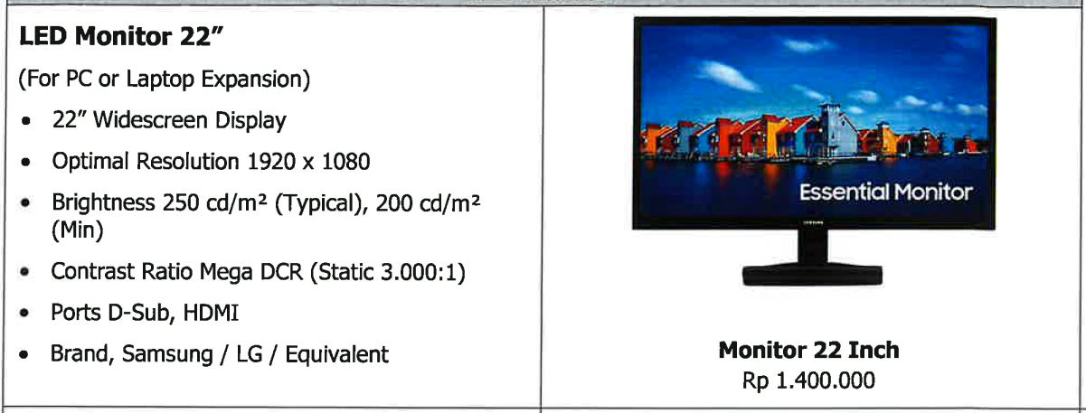

1. **LED Monitor 24”**

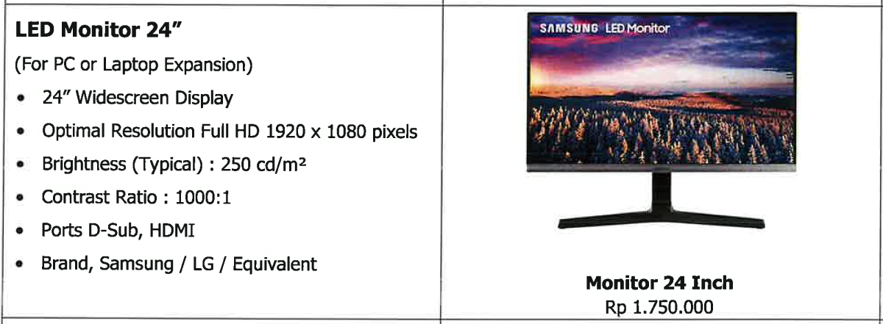

1. **LED Monitor 27”**

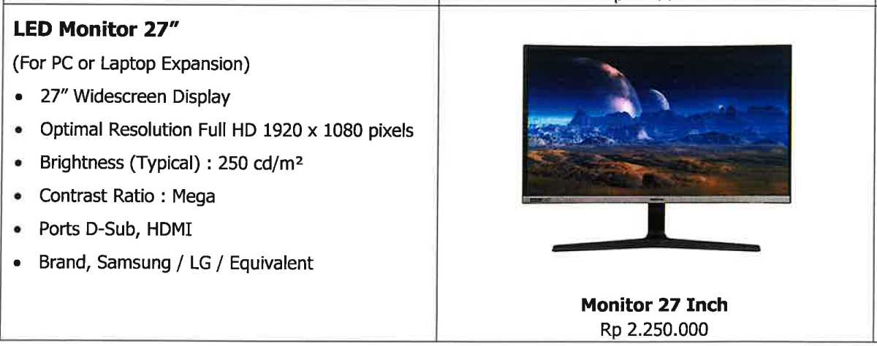

### Network Types: The types of network device used within the company network, enabling the network performance to be secure and reliable. MTI categorizes devices as follows:

### IT Communication Device Types: The types of IT Communication device used within the company area, enabling the communication to run smoothly and reliable. MTI categorizes devices as follows:

1. **Desk Phone** – for communication using telephone system allocated on the user desk, suitable for office user and Central Control Room.

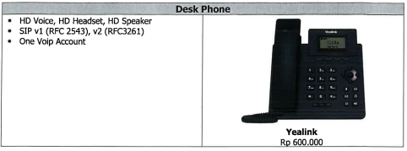

1. **Radio HT** – for radio two-way communication handy talkie to communicate between employee within Company Area to support working activities.

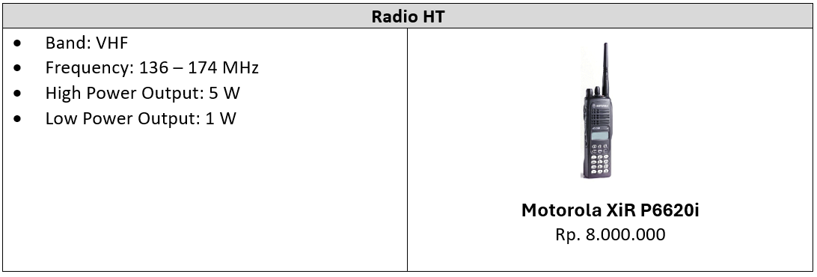

1. **Radio Rig / Mobile Unit** – for radio two-way communication install on the mobile unit and office desk.

### Standardization: All computers and IT communication devices of the same type must come from the same brand to ensure compatibility and simplify support and maintenance.

### Nonstandard Computers: Request for a computer different from the standard determined by the IT department must be justified in the out of policy form request and subject to approval from GM of IT.

### Data Ownership: All data stored on company computers or notebooks is wholly owned by MTI.

### Inspection Rights: MTI has the right to examine employee computer equipment registered as company assets, with the approval of internal audit or company management.

### Ownership of Document Files and Work Produced:

**Explanation:**

Any files, documents, or other outputs produced by employees during their work, whether stored on personal devices, company-provided computers or cloud storage are considered as company property.

**Scope. This includes:**

* Reports, presentations, spreadsheets, and technical documents created for work.
* Software code, scripts, or configuration files developed for business purposes.
* Emails, messages, or correspondence sent from company accounts or containing company-related information.
* Any content or intellectual property created using company resources or as part of company-directed projects.

**Data location and Storage:**

Employees may store files on both personal and company devices; however, these files remain MTI’s property. This also applies to data in company-sanctioned storage solutions, such as OneDrive or company servers.

**Access and Retrieval Rights:**

MTI reserves the right to access, retrieve, and examine these files if necessary. This applies in situations such as:

* Audit or internal investigations.
* Security or compliance checks.
* Employment termination, to ensure retrieval of all work-related content.

**Confidentiality and Security**

Employees must handle and secure work files according to MTI’s confidentiality and security guidelines, ensuring proprietary information is protected from unauthorized access.

**Termination and Exit Process**

Upon termination or resignation, employees must return all work-related files to MTI. They are not permitted to delete, retain or transfer these files unless explicitly authorized.

## Replacement and Maintenance Standards

### Replacement Criteria

Laptop will be considered for replacement under the following conditions:

1. **Performance issue –** Devices with unresolved performance issues that cannot be economically upgraded. For example, laptop’s speed is becoming slow and unresponsive, especially when opening or running applications that require a lot of memory can be replaced if it cannot be repaired or upgraded adequately.
2. **Physical damage –** Devices with irreparable physical damage. For example, laptop with physical damage such as cracked screens, motherboard, or port malfunctions, may be replaced if they cannot be repaired cost-effectively.
3. **High Maintenance Needs –** Devices with frequent repairs that exceed the cost of a new laptop.
4. **Software Incompatibility –** Computers unable to support essential software. Laptop that are no longer compatible with the latest software version that is related to the main work function, in this case, will be given the option to be replaced according to needs.
5. **Loss or Theft –** Laptop that are lost or stolen, provided the employee reports the incident to the IT department immediately and files a policies report.

### Maintenance Responsibility

**User Accountability for Damaged Assets**

**General Care Requirement**

Employees are responsible for handling and caring for all company-provided devices (computers, bags, and peripherals). Users are expected to follow best practices to maintain device condition, including keeping equipment clean, avoiding exposure to extreme conditions, and securely storing devices when not in use.

**Responsibility for Damage Due to Negligence**

If damage occurs due to user negligence, misuse, or failure to follow care guidelines, the employee will be responsible for covering repair or replacement costs. Below are examples of negligence including, but are not limited to:

* **Physical Damage:** Dropping a device, spilling liquids, or mishandling equipment in a way that leads to crack, dents or other physical impairments.
* **Environmental Exposure:** Leaving devices in extreme temperatures or unsafe environments, leading to internal or external damage.
* **Unauthorized Modifications:** Attempting repairs, upgrades, or modifications without approval from the IT department.

**Replacement Costs based on Depreciation**

To ensure fair charges, the cost for replacement of a damaged device will take into account the devices depreciated value as outlined in **Depreciation Policy (Section 5.3)**

* Depreciation Rate: Company-issued computers and notebooks have a 4-Year depreciation period. This device’s value reduces by 25% per year.
* Example: If an employee damages a notebook that is two years old, the replacement cost will be 50% of its original purchase price, reflecting two years of depreciation.

**Intentional or Repeated Damage**

If it is found that the damage was intentional or that the employee has a history of frequent or repeated damage due to negligence, the employee may be subject to disciplinary action in addition to covering repair or replacement costs. This could involve further internal review and potential consequences as deemed appropriate by company management.

**Process for Reporting Damage**

Employees must report any damage to their assigned equipment to the IT department immediately. The IT department will assess the damage and determine whether repairs or replacement are necessary. If user negligence is identified as the cause, the employee will be informed of their financial responsibility for any costs incurred.

**Peripheral Allocation and Maintenance**

**One-Time Peripheral Allocation**

Each employee is provided with a mouse **only once** upon issuance of new computer or notebook

* **Replacement Responsibility:**

Any damage to peripherals, whether due to user negligence or normal wear and tear, will be the responsibility of the user. Employees are required to cover the full cost of replacing any damaged or lost items.

* **Policy Reminder:**

This is a one-time provision policy. Any additional replacements needed for peripherals will be at the employee’s expense.

**Returning Equipment**

Upon resignation, role transition, or device replacement, employees must return all company-provided equipment, including peripherals, to the IT department. Failure to return equipment or peripherals may result in a deduction from the employee’s final settlement.

## Depreciation Policy

This policy establishes the standards for depreciating company-issued computers and related assets at PT. Merdeka Tsingshan Indonesia (MTI). Depreciation is used to calculate the reduced value of assets over time, ensuring fair replacement costs in case where user responsibility applies.

### Purpose

The purpose of this policy is to:

Ensure that the replacement cost for company assets reflects the fair market value based on usage and age.

Provide a clear method for calculating depreciation on IT equipment such as computers notebooks, and other hardware.

Encourage employees to maintain their devices, understanding that replacement costs for negligence will consider depreciation.

### Depreciation Method and Period

**Straight-Line Depreciation**

MTI uses a straight-lines depreciation method, where the assets value decreases at a fix rate each year over its useful life. This method provides a simple, consistent approach for calculating the asset’s depreciated value.

**Useful Life of IT Assets**

* Computers and Notebooks: 4 Years
* Other Equipment (e.g., specialized devices or high-performance machines): Useful life may vary based on the nature of the equipment and will be defined by the IT department upon purchase.

**Annual Depreciation Rate**

* **Computers and Notebooks**

These assets are depreciated over a period of 4 years (48 months) at a rate of **2.08% per month**. After 48 months, the asset is considered fully depreciated and as a book value of zero.

|  |  |  |
| --- | --- | --- |
| **Month** | **Depreciated Value** | **Remaining Value** |
| 0 | 0% | 100% |
| 1 | 2.08% | 97.92% |
| 6 | 12.5% | 87.5% |
| 12 | 25% | 75% |
| 24 | 50% | 50% |
| 36 | 75% | 25% |
| 48 | 100% | 0% |

**Depreciation-Based Replacement Costs**

When an asset requires replacement due to **negligence or intentional damage by user**, the replacement cost to be borne by the employee will be based on the asset’s **remaining book value** after depreciation.

**Example Calculation**

If a laptop originally costing $1,000 is damaged due to user negligence after 2 years:

* Original Value: $1,000
* Depreciated Value After 2 Years (50%): $500
* Replacement Cost to User: $500

**End-of-Life and Disposal**

* **End-of-Life**

Once an asset is fully depreciated (i.e., after the 4-year depreciation period), it is considered to have reached the end of its useful life. However, MTI may continue to use the asset as long as it remains functional.

* **Disposal**

Fully depreciated assets that are no longer functional or economically viable for repair will be disposed of following the **Write-Off Process**. Employees are not liable for costs related to the disposal of fully depreciated assets unless intentional damage is determined.

**Exceptions and Special Cases**

* **High-Performance Devices**

Certain high-performance or specialized devices (e.g., engineering workstations, rugged field notebooks) may have different depreciation schedules depending on their usage and maintenance needs. The IT department will set specific depreciation rates and periods for these devices.

* **IT Department Discretion**

The IT department reserves the right to adjust the depreciation period of an asset if it is deemed necessary due to usage intensity, upgrades, or operational needs. Changes will be documented, and the employee will be informed of any adjustments that may affect replacement costs.

**Responsibility and Compliance**

Employees must acknowledge their understanding of the Depreciation Policy upon issuance of a company asset. Any disputes regarding depreciation rates or replacement costs will be addressed by the IT and Finance departments in accordance with this policy.

## Budgeting Computers

### Annual Budget Allocation

User departments must allocate an annual budget for additional computers, depending on the projected need for extra computers in the following year.

### Upgrading Computer Types

Additional computers may include upgrading types of computers. For example, replacing standard desktop computers with high-performance desktops or converting from standard desktop computers to notebooks to meet specific needs.

**Budget Responsibility:** Any upgrade in computer type shall be covered by user’s department budget.

**Approval Process:** Requests for upgrades outside the standard policy must be submitted using the “Out of Policy Request Form”

### Budget Planning Process

The annual computer budgeting process must align with the practices of each business unit, taking into account allocations for new employees or additions based on Manpower Planning (MPP).

## Other Provisions

**Support for Private Computers**

The IT Department will not provide any support for private and third-party computers. Only company-issued computers are eligible for IT support services.

**Standardization of Computer Types and Brands**

The IT Department will not facilitate the purchase of computers that differ in type or brand from the established standard for company devices. Only approved types and brands may be purchased to ensure consistency and compatibility.

# Appendix

## Service Request Form

](https://merdekabattery.sharepoint.com/sites/intranet-mti/Shared%20Documents/Human%20Resource/Forms/MTI-HRM-ICT-FRM-002_Rev.000%20-%20Service%20Request%20Form.docx)

## Out of Policy Form

## Berita Acara Kerusakan / Kehilangan Form

](https://merdekabattery.sharepoint.com/sites/intranet-mti/Shared%20Documents/Human%20Resource/Forms/MTI-HRM-ICT-FRM-004_Rev.%20000%20-%20Berita%20Acara%20Kerusakan_Kehilangan%20Barang%20IT.docx)

## Disposal / Write-Off Form

|  |  |
| --- | --- |
|  | |
|  |